**Moon and Cake Team Roles**:

Max Yeh: Product Owner, Scrum Master (rotated)

Yao-Wen Chang

Jinson Wu

Yi-Chia Wu

Ya-Ru Yang

**Customer Meeting Date/Time/Place**:

weekly meeting: 11/30, 12/02 via Zoom (9:00-10:00 am every Friday via Zoom)

**Feedback from the Client (mainly from the meeting on 12/02):**

* test

**Current Working Stories**:

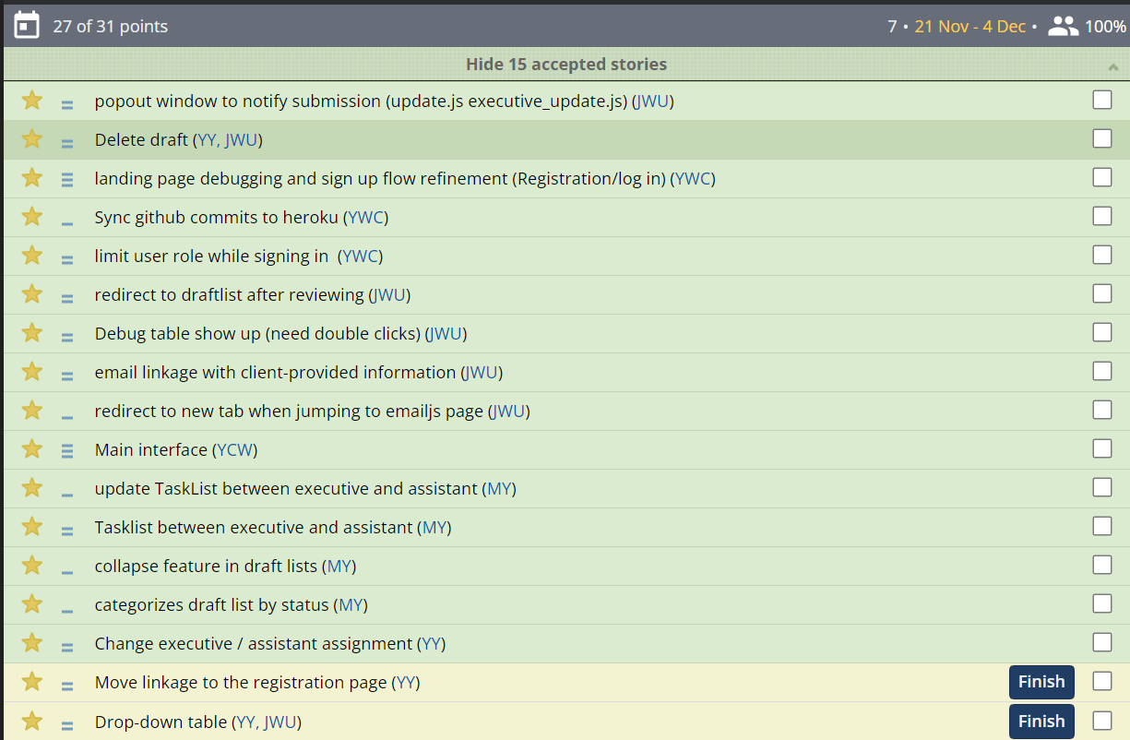

* Debug table shows up.
* Email linkage with client-provided information
* Main interface update. New picture on the login page, rearrange the position.
* Draft lists replacing Audio files as communication between the executive and assistant
  + Adding categories drafts by status.
  + Adding collapse button
* Change executive / assistant assignment
* UML class diagram

